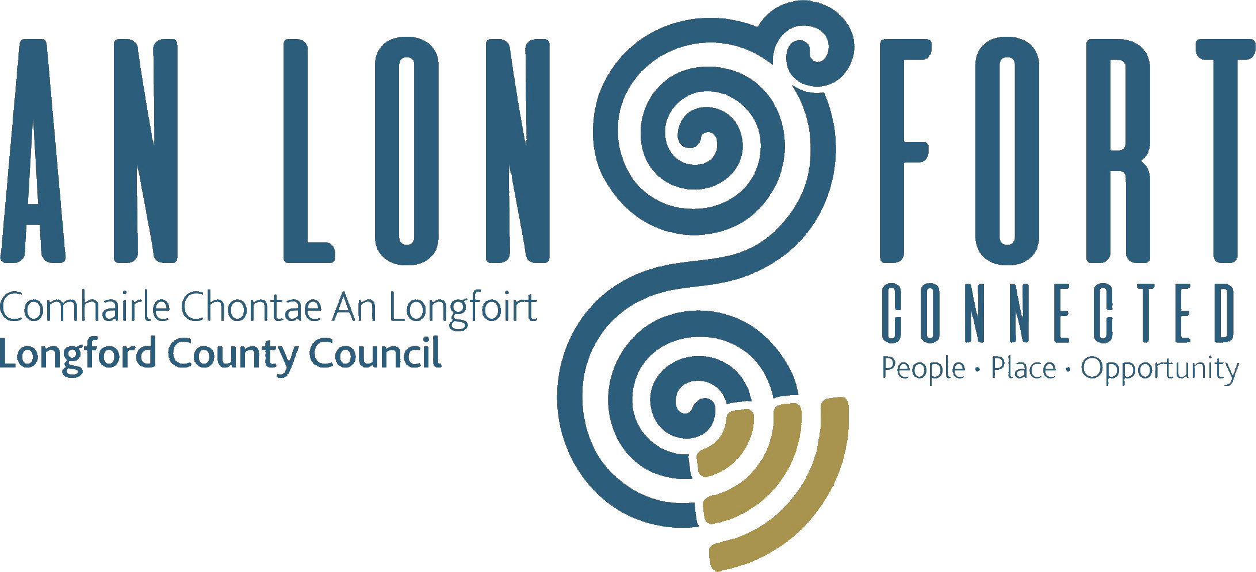

BALLYMAHON MUNICIPAL DISTRICT

Minutes of Meeting of Ballymahon Municipal District held in the Council Chamber, Aras an Chontae, Longford on Friday, 14th February 2020 at 2.30 p.m.

CATHAOIRLEACH: Councillor Pat O’Toole.

MEMBERS PRESENT: Councillors – Mick Cahill, Mark Casey, Gerard Farrell,
Colm Murray and Paul Ross.

IN ATTENDANCE: Ms. Barbara Heslin, Director of Services.
Ms. Linda Higgins, Administrative Officer.
Mr. Paul Newell, Senior Executive Engineer.
Mr. P.J. Gill, Executive Engineer.
Mr. John Doyle, Technician.

MEETINGS
ADMINISTRATOR: Ms. Anne. Lee.

P. Newell briefed the members on the Schedule of Ballymahon Municipal District Works under the following headings and replied to queries raised by the members –

- TII Grant.
- Restoration Improvement Grant
  - Regional Roads.
  - Local Roads.
- Restoration Maintenance Grant
  - Regional Roads
  - Local Roads.
- Supplementary Restoration Maintenance Grant Total County Allocation.
  - Regional Road.
  - Local Roads.
- Discretionary Grant.
- Low Cost Safety Scheme.
- Bridges.
- Specific Improvement Grant.
- Drainage Grant Total County Allocation.
  - Local Road.

On the proposal of Councillor M. Cahill seconded by Councillor C. Murray, it was unanimously agreed to adopt the Schedule of Ballymahon Municipal District Works, as circulated.

This concluded the business of the meeting.
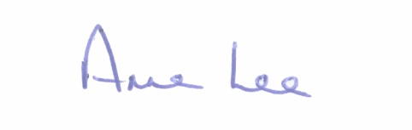

Signed: __________
Anne Lee,
Meetings Administrator.

Confirmed and adopted at Ballymahon Municipal District Meeting held on the
7th April 2020.

Signed: _______________
Cathaoirleach.

